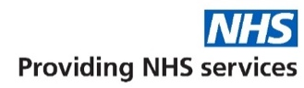
Teaching practice
The practice is a teaching practice and occasionally trainee GPs, Medical Students and others may, as part of their training, be required to sit in with their trainer GP during consultations with patients.

You will always be asked if you consent to this prior to your consultation. If you do not consent, the trainee GP or other will not sit in on your consultation.

How to register at the practice
The quickest way to register at the practice is to use the practice website. You must live within the practice area which is shown on the website. If you are unable to use the website, please contact the practice for information about how to register alternatively you can visit the practice in person making sure to bring along some form of ID (passport/ drivers license or utility bill).

Patients’ rights and responsibilities
When registering, you have a right to express a preference to be seen by a particular GP. This will be recorded on our clinical system and, where possible, you will be allocated appointments with that clinician. All patients will be assigned an accountable GP.

You will also be offered a health check when you join the practice for the first time (see the practice website for a full list of your rights and responsibilities).

Interpreting services
If you require an interpreter, please let the receptionist know when booking an appointment so the clinician can arrange an interpreter for you.

Requesting a chaperone
If you would prefer a chaperone, please let the receptionist know when booking your appointment.
Patient Information Leaflet


Mark Street Surgery is a partnership providing NHS Services under an NHS England General Medical Services Contract.
Mark Street Surgery
2 Mark Street
ROCHDALE
OL12 9BE
Telephone No: 01706 643 183
Email:
gmicb-hmr.markstreetsurgery@nhs.net
Prescription Email:
gmicb-hmr.prescriptions.p86008@nhs.net
Website:
www.markstreetsurgery.co.uk

GP services are provided
to the following areas:

Opening hours
Mon–Friday* | 8.00am | 6:30 pm
Saturday | closed
Sunday | closed

*Excluding bank holidays

Improved access/Extended hours

Mon–Friday | 6.30pm | 9.30pm
Saturday | 9am | 5pm
Sunday | 10am | 4pm

Services we
Along with routine appointments, the practice offers the following services:

- Family planning – All our GPs and the practice nurse offer a full range of family planning services
- Immunisations – The nursing team administers vaccines for both adult and child immunisations.
- Minor surgery – Your GP will advise on minor operations
- Cervical smear testing – For women aged 25 – 65. These tests are undertaken by the nursing team.
- Chronic disease management – We hold a range of clinics to help our patients to manage their long-term medical problems including asthma, diabetes, hypertension, kidney disease and heart disease.
- Other services – Health checks for adult patients aged 16 to 74 years and 75 years and over are also available especially for those who have not seen a clinician at this practice. Details are available from reception and on the practice website.

We also offer the following clinics and checks: antenatal, baby, post-natal.

From time to time, other services may be available such as raising awareness of a particular disease or condition. We will advertise this information on our website and within the practice.

Accessibility
Here are Mark Street we are very inclusive and offer disabled toilets at ground floor level and an induction hearing loop for those who have hearing impairments.

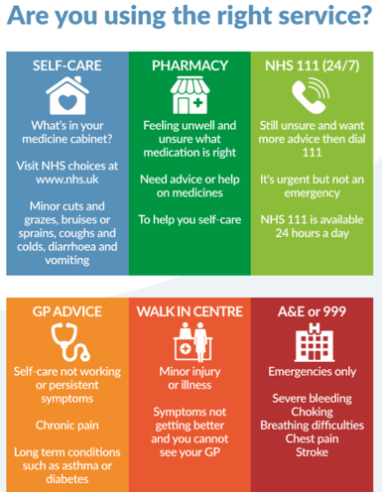

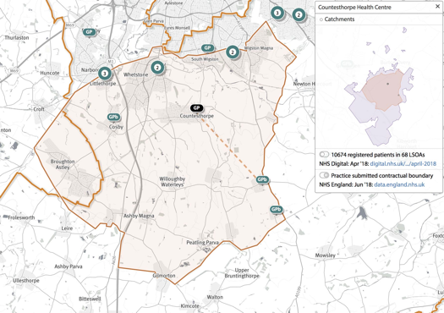

Further information can be sought from www.nhs.uk

Appointments and accessing practice services

To make a routine appointment to see your GP or any member of our healthcare staff or if you have a routine enquiry, you can contact us via Patchs. You can then complete an online form which will be actioned within 24 hours and is accessible weekdays from 8am – 6.30pm. Alternatively, you can ring 01706 643 183 and a member of our administrative staff will be able to assist you.

You can book routine appointments at least 2 weeks in advance by accessing the NHS app.

If you require an on the day appointment our lines open at 8am and the member of staff can triage you accordingly.

For further guidance please visit our practice website which contains all the relevant practice information that you are likely to require. It is the quickest way to access the services you may need.
Threats of violence or abuse of our staff
Our staff work hard to provide you with the best possible service. Please treat them with the courtesy and respect they deserve. We operate a zero-tolerance policy and may refuse to provide services to individuals or those accompanying individuals who are violent, threaten violence, commit, or threaten to commit a criminal offence

Patient Participation Group
We have an active Patient Participation Group (PPG), ensuring that our patients are involved in decisions about the services provided by the practice.

Further information about our PPG is available online at Markstreetsurgery.co.uk.

Alternatively, contact Aliya (Office Manager) who is the nominated point of contact for all PPG matters.

Patient data
All clinical and administrative staff have an ethical as well as a legal duty to protect patient information from unauthorised disclosure and in accordance with UK GDPR.

The patient privacy notice is available on the practice website.

Online services
You can access your appointments, order prescriptions and view records all on the NHS app. You can also book routine appointments up to 2 weeks in advance.
For further information please visit our website or contact the practice.

You can also contact us via Patchs, here you can fill out an online form which will be actioned within 24 hours and is accessible from 8am-6.30pm on weekdays (excluding bank holidays)

Comments, suggestions and complaints
If you would like more information about any of the services we provide, please ask a member of staff, telephone or log into the practice website. Details are shown on the front of this leaflet.

Our aim is to give the highest possible standard of service. We would like you to tell us what you think about the service we

Home visits
Home visits are at the discretion of the GPs and are usually for those patients who are housebound or have significant health issues. Should you require a home visit, please contact reception using option 2 requesting a call-back after logging a call before 10.00 am. A clinician will then telephone you to discuss your request.

Home visits are usually carried out after 12:00 pm, Monday to Friday. NB or after pm surgery
When we are closed
When the practice is closed, if you urgently need medical help or advice and it is life threatening, dial 999. If it is not life-threatening, contact NHS 111 by calling 111 or accessing via www.nhs.uk

PLEASE NOTE: We close the doors for training at 12.30pm and the phone lines close in the afternoon at 1pm on the 2nd Thursday of every month.

NHS England Contact
Mark Street Surgery provides NHS services on behalf of NHS England, PO Box 16738, Redditch, B97 9PT.

Telephone: 0300 311 2233
Email: england.contactus@nhs.net

This leaflet was produced from the Patient Information Leaflet Policy dated 23/11/2022 and last updated 22/10/2025

We also offer the following clinics and checks: antenatal, baby, post-natal, smoking cessation, counselling for drug and alcohol addiction.

From time to time, other services may be available such as raising awareness of a particular disease or condition. We will advertise this information on our website and within the practice.

Prescriptions/repeat prescriptions
Your GP will initiate any prescription that they determine you require. Repeat prescriptions can be ordered in the following ways:

- In person – By ticking the required medications on your prescription and placing it in the dedicated box, located in the foyer of main reception.
- By Email – Email your request to: gmicb-hmr.prescriptions.p86008@nhs.net along with your name and date of birth.
- NHS app – Please log in and order requested items. If you need help signing up, please visit the surgery and we can provide guidance.
- Patchs service – Sign up through our website and order prescriptions through an online form.

Please allow 48 working hours for collection when ordering repeat prescriptions.

The practice team
This practice operates under a partnership agreement and provide services on behalf of the NHS.
Partners
Dr Sinead Reid: MB ChB (Liverpool 2004). MRCGP DFSRH (LOC in subdermal implants) PGCE (Medical Education). GP Trainer
Dr Matthew Titterton: MB ChB (Leicester 2003) MRCGP
Dr Htin Maung: MB ChB (Liverpool 2014) MRCGP 2014
Salaried GPs
Dr Andrew Parton: BSc (Hons) MB ChB (Liverpool 1987) DCH DRCOG DFFP MRCGP (Merit).
Dr Oluwafemi : MBBS (Okada) MRCGP (2014) PG Diploma in Diabetes
Dr Habiba Zaman: MB ChB (Liverpool 2010), MRCGP (Hons)
Dr Hassan Saleem: MBChB (Liverpool2011)
Advanced Practitioner
Sr Alison Williams: RGN, Asthma diploma, COPD diploma, CHD diploma, Heart Failure course, BSc (Hons) Community Health -General Practice Nursing
Nurses
Kate Howarth: RGN, Asthma Dip, Diabetes/Cardiovascular Dip Smoking Cessation adviser. Kate qualified as a Nurse Prescriber in 2017
Lauren Maden: BSc (Hons) Adult Nursing
Other healthcare staff
Stephanie Mayberry: Nurse Associate
Sarah Gumbley: Nurse Associate
Liz Speddy: Health care assistant

Management Team
Rachel Critchlow: Operations manager

Sarah Hulmes: Business and finance manager

